Set 20: Stock Analysis

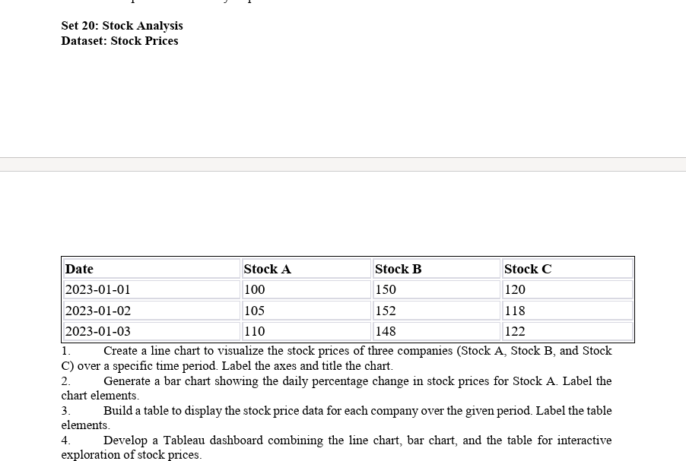

Question 1: Create a line chart to visualize the stock prices of three companies (Stock A, Stock B, and Stock C) over a specific time period. Label the axes and title the chart.
Aim:
To create a line chart in R to compare the stock prices of Stock A, Stock B, and Stock C over the given dates.
Code:
# Import stock data
stock_data <- read.csv("Stock_Prices.csv")
stock_data$Date <- as.Date(stock_data$Date)

# Line chart for three stocks
matplot(stock_data$Date,
stock_data[, c("Stock A", "Stock B", "Stock C")],
type = "b", pch = 19, lty = 1,
col = c("blue", "red", "darkgreen"),
xlab = "Date", ylab = "Stock Price",
main = "Stock Prices Over Time")
legend("topleft", legend = c("Stock A", "Stock B", "Stock C"),
col = c("blue", "red", "darkgreen"), lty = 1, pch = 19)
Output:
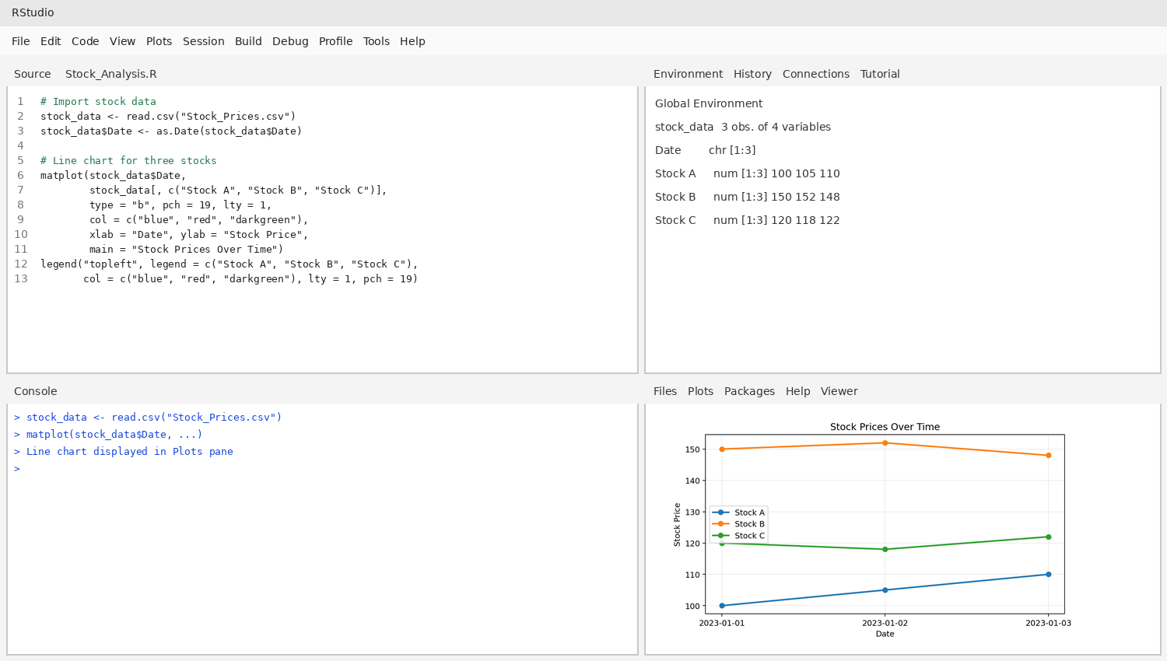
RESULT:
Thus, a line chart was created successfully to visualize and compare the stock prices of the three companies over the given period.

Question 2: Generate a bar chart showing the daily percentage change in stock prices for Stock A. Label the chart elements.
Aim:
To calculate the daily percentage change in Stock A and represent the changes using a labeled bar chart.
Code:
# Calculate daily percentage change for Stock A
stock_data <- read.csv("Stock_Prices.csv")
stock_data$Date <- as.Date(stock_data$Date)

change <- c(NA, diff(stock_data$`Stock A`) /
head(stock_data$`Stock A`, -1) * 100)
change[1] <- 0

barplot(change,
names.arg = stock_data$Date,
col = "skyblue",
main = "Daily Percentage Change in Stock A",
xlab = "Date", ylab = "Percentage Change (%)")
Output:
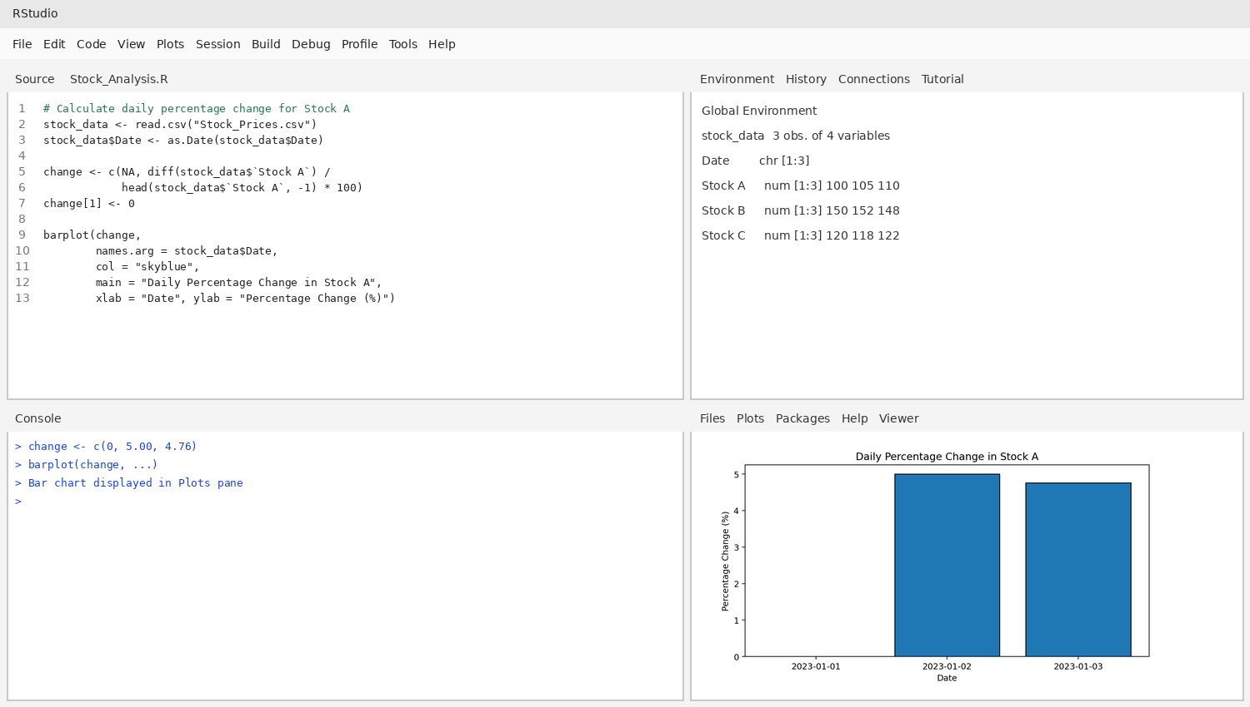
RESULT:
Thus, a bar chart was generated successfully to display the daily percentage change in Stock A. The price increased from 100 to 105 (5.00%) and from 105 to 110 (approximately 4.76%).

Question 3: Build a table to display the stock price data for each company over the given period. Label the table elements.
Aim:
To create and display a table containing the date and stock prices of Stock A, Stock B, and Stock C.
Code:
# Create and display stock price table
stock_data <- read.csv("Stock_Prices.csv")

print(stock_data)
Output:
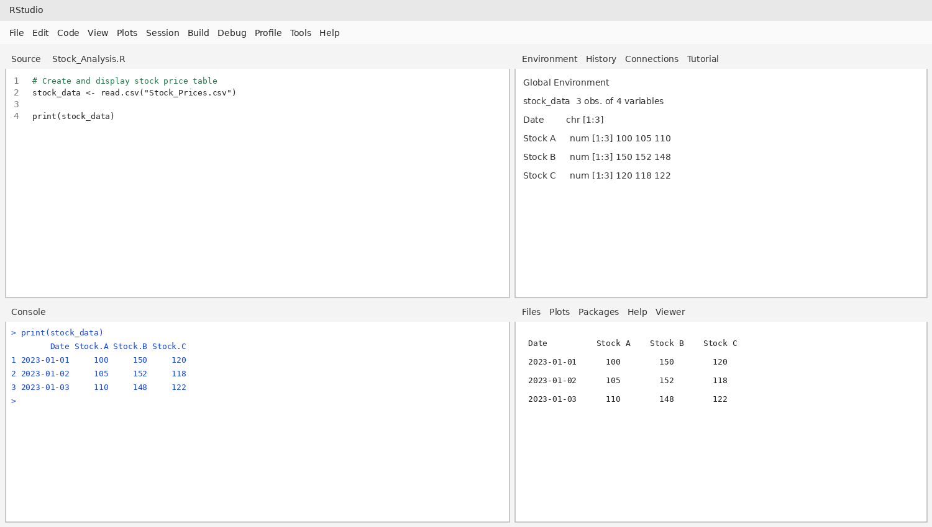
RESULT:
Thus, a stock price table was created successfully with dates and the corresponding prices of all three companies.

Question 4: Develop a Tableau dashboard combining the line chart, bar chart, and the table for interactive exploration of stock prices.
Aim:
To create a Tableau dashboard that combines the stock price line chart, Stock A daily percentage change bar chart, and stock data table.
Procedure:
- Open Tableau and connect to Stock_Prices.csv using the Text File connector.
- Create the line chart by placing Date on Columns and Stock A, Stock B, and Stock C on Rows. Use Line marks.
- Create a calculated field for Stock A daily percentage change: (Stock A - LOOKUP(Stock A, -1)) / LOOKUP(Stock A, -1) * 100. Use it in a bar chart by Date.
- Create a text table with Date, Stock A, Stock B, and Stock C.
- Create a dashboard and add the line chart, bar chart, and table. Add Date and Stock filters if required.
Output:
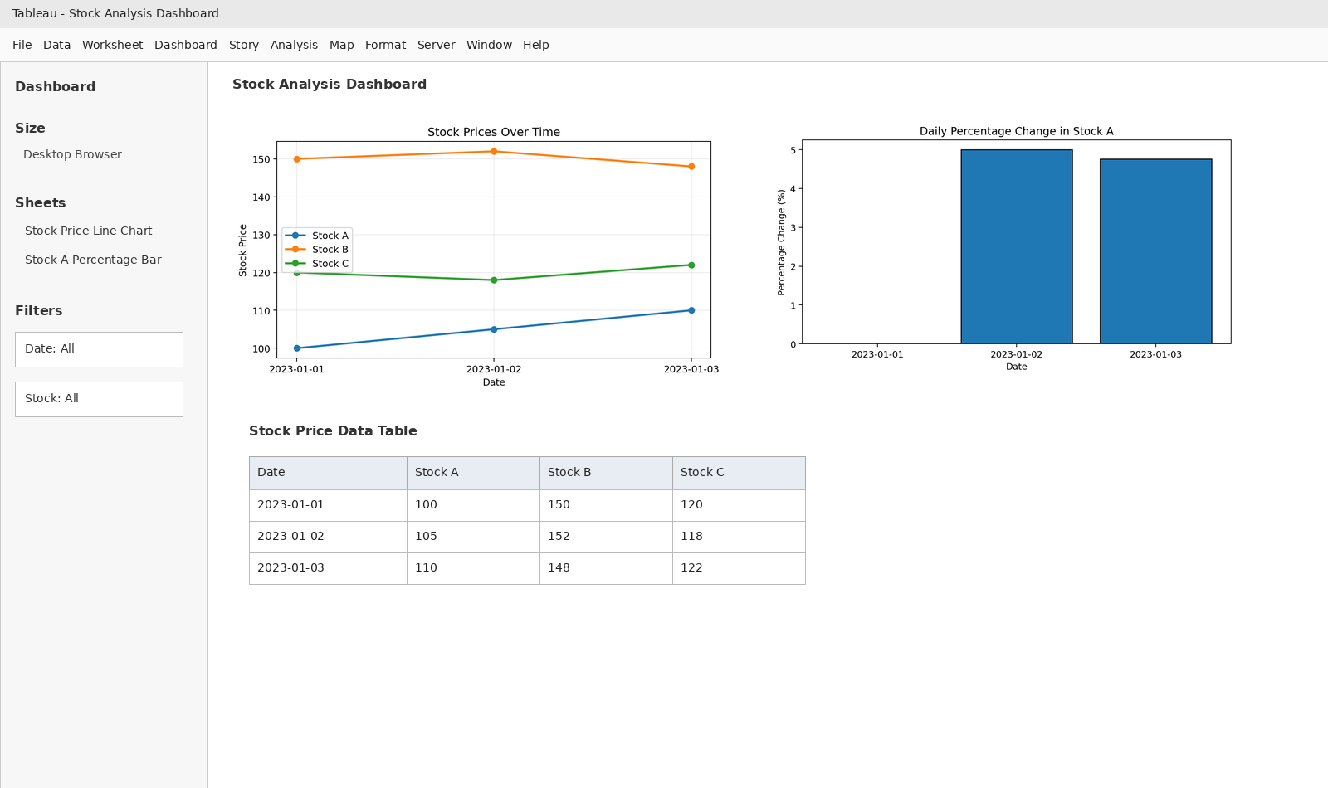
RESULT:
Thus, a dashboard-style output was prepared by combining a line chart, bar chart, and stock price table. The image illustrates the intended layout; create the actual interactive dashboard in Tableau using the procedure above.

